SWE20001 – Development Project 1: Tools and Practices

Team Report For Week 1

HENRY TRAN 102075482

Lab: Friday 2:30pm

Tutor: Huai Liu

Team number: 3

Henry Tran 102075482

Edward Knight 102700043

Duy Phuong Nguyen 101204984

Christian Ilott 102169762

**Activity 1.1. Team formation and To Do process:**

The following photos (**with annotations for explaining what we did**) capture the process our team used to perform the tasks required in Activity 1.1:

Slack Categories Created by Henry

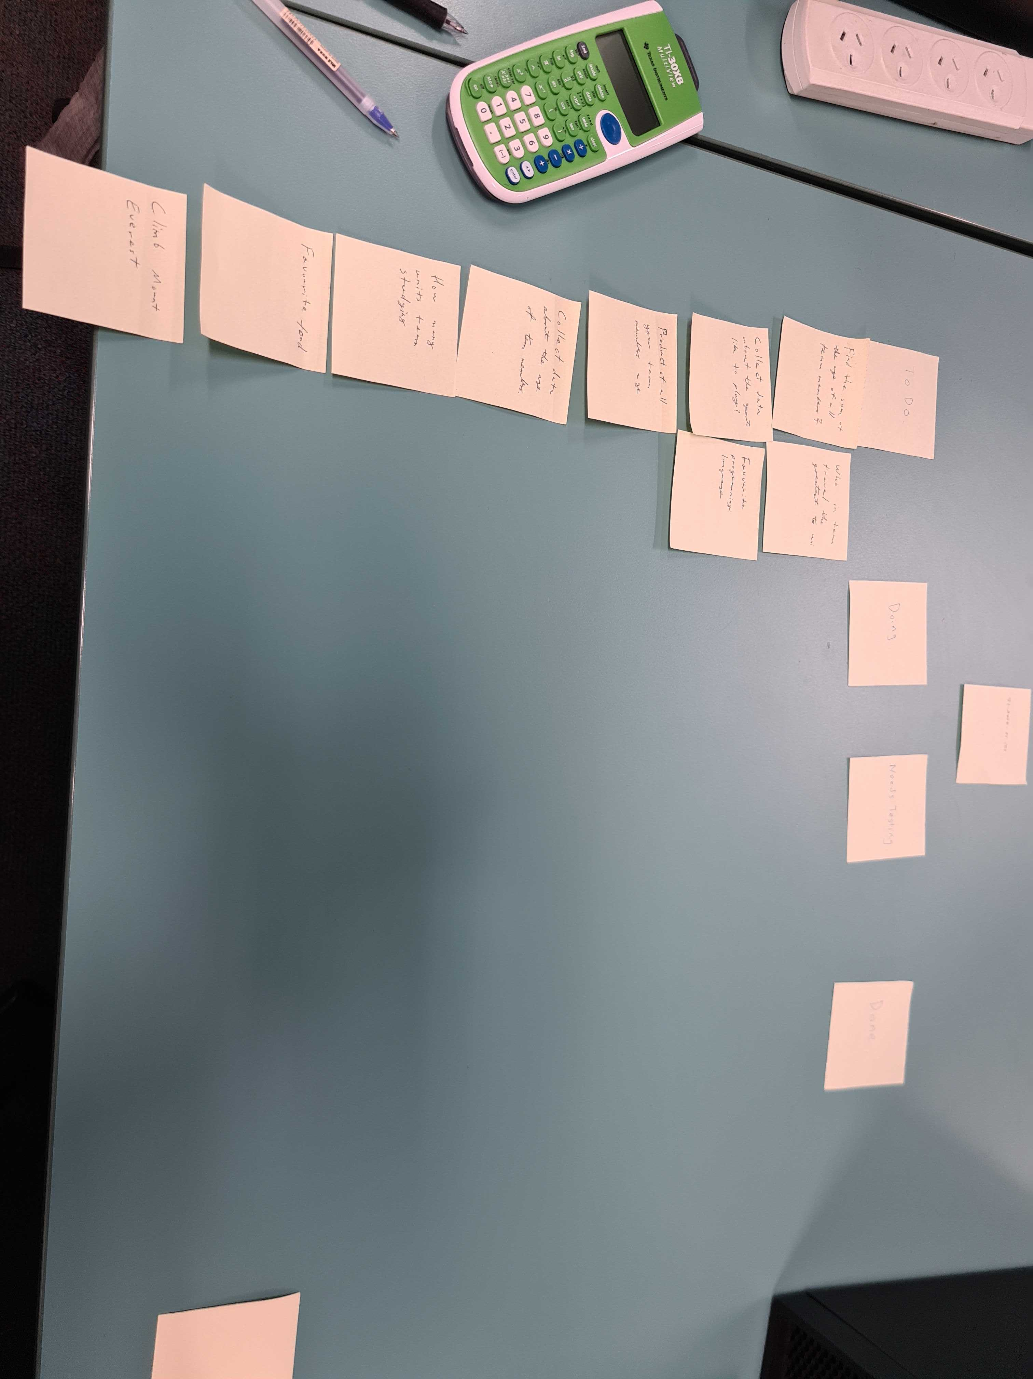

Tasks created and added to the To Do category by Christian.

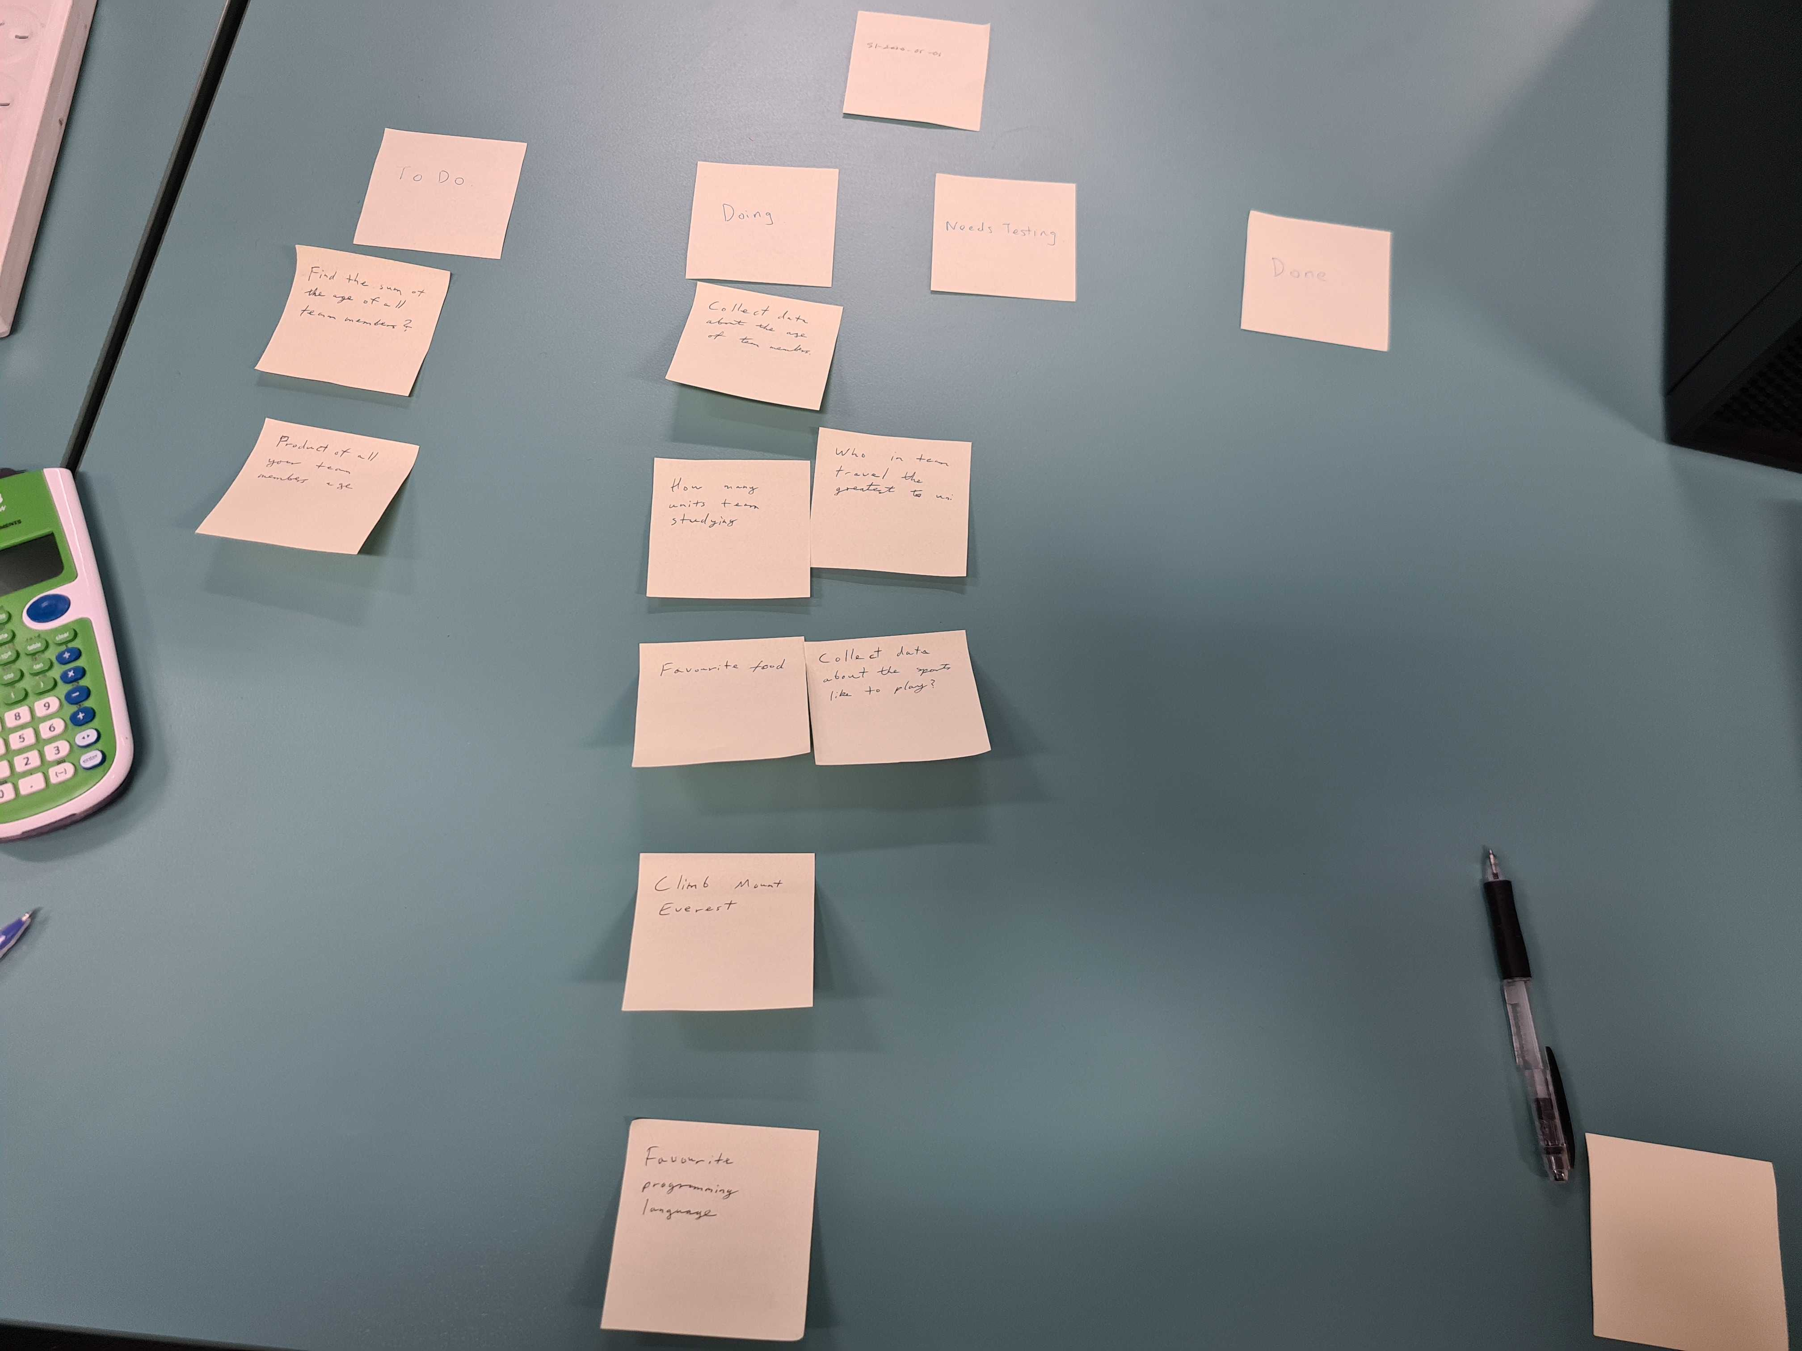

Tasks moved to Doing category by Henry and information collected.

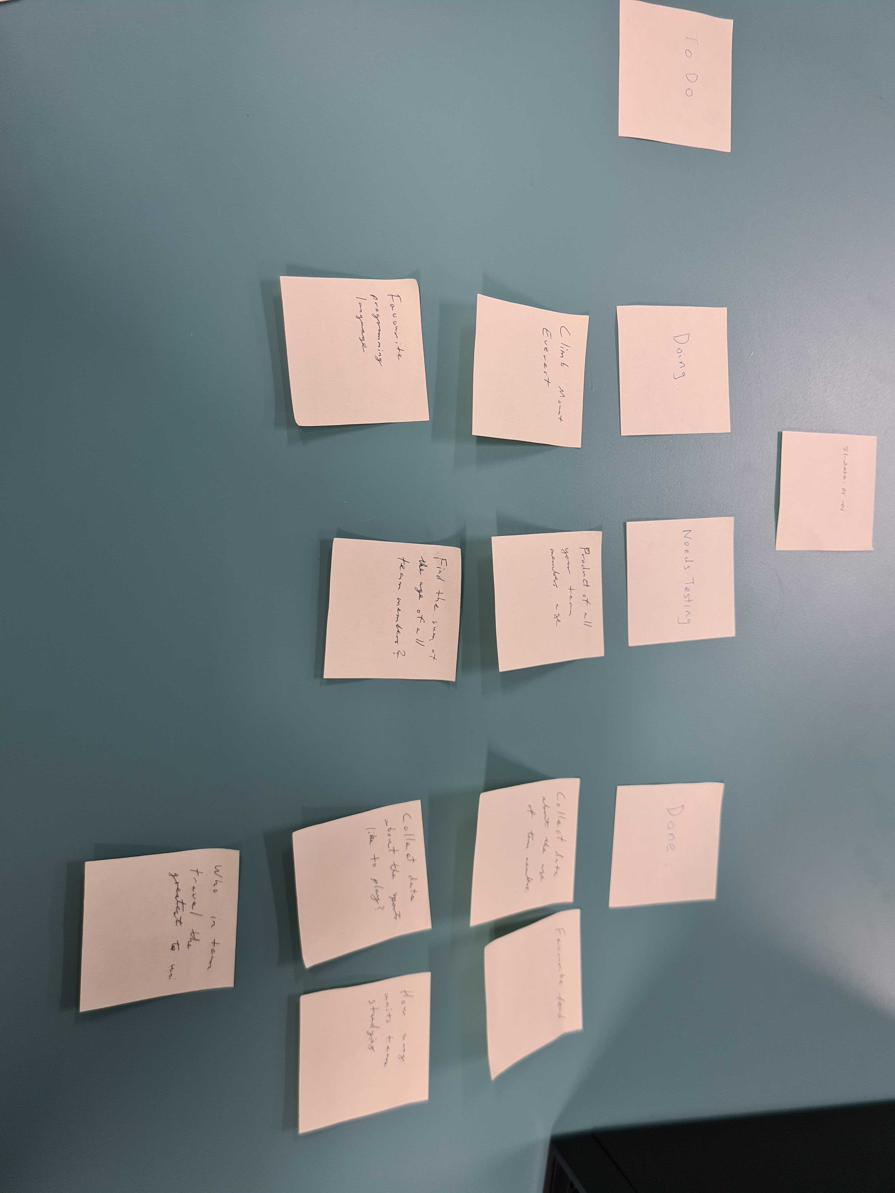

Completed tasks are moved to the Done category and sum and product of ages tasks moved to the Needs Testing category.

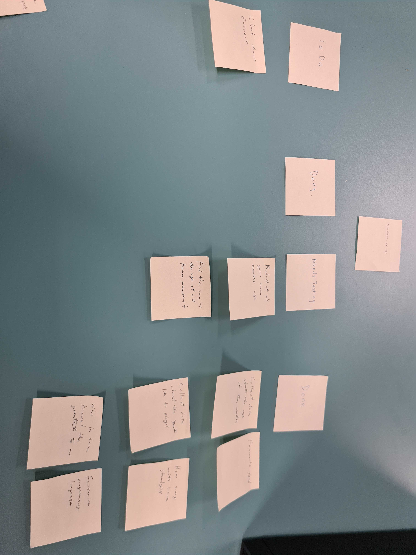

Product and sum of ages is verified by Edward before being moved to the Done category.

Tasks have been moved to Done if completed and unsure tasks (Climb Mt Everest) left in the To Do category.

**Activity 1.3. Team scenarios discussion:**

After practicing to use Slack for team communication, we were assigned a team scenario for discussion. The scenario our team needed to consider was:

Miscommunication between two members of the team who were unsure of what task each person was assigned to do that week. One person was waiting for information from the other before completing the task but it is unsure if this was agreed on during the meeting.

Our team came up with the following ideas (and also had debates on each idea) for resolving this situation as follows:

* Idea 1: Improve communication within the group using tools such as facebook messenger, slack or trello.
  + Arguments for: Allows group members to confirm tasks and follow up with other members when situations arise.
  + Arguments against: None
* Idea 2: Clearly define tasks at the meeting and write them down so that everyone knows exactly what they are doing.
  + Arguments for: Written down tasks can be used as proof in case of arguments.
  + Arguments against: None

After careful consideration, our team agrees to adopt idea 1 and 2 should a similar situation happens to our team.